Heat map – Face covering correlation to the data:

URL:

<https://ourworldindata.org/covid-face-coverings>

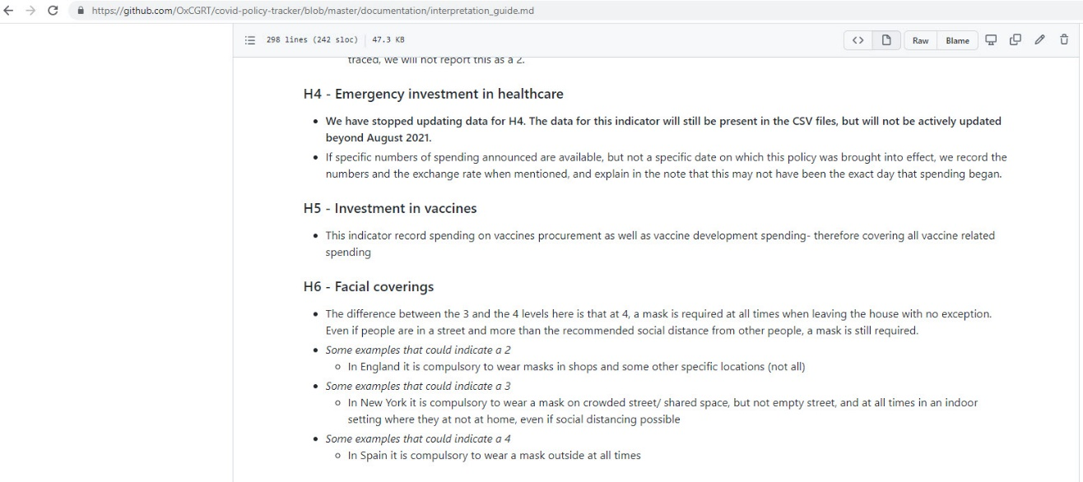

<https://github.com/OxCGRT/covid-policy-tracker/blob/master/documentation/interpretation_guide.md>

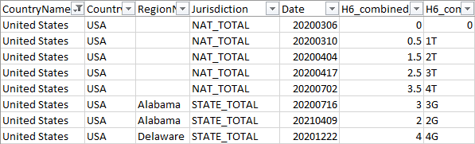

|  |  |  |
| --- | --- | --- |
| **Policy level** | **Index** | **Map color** |
| No policy | 0 | Blue |
| Recommended | 1 and 0.5 | Light Yellow |
| Required in some public spaces | 1.5 and 2 | Orange |
| Required in all public spaces | 2.5 and 3 | Mustard |
| Required outside-the-home at all times | 3.5 and 4 | Burgundy |

